Directions: Replace all yellow highlighted text with information specified.
Name
<Insert Name Here>

Part 1 - Photovoice Reflection Prompts
Directions: Please respond to the photovoice reflection prompts using three pictures (e.g., photo) and writing a narrative (e.g., voice). The narrative (minimum of 200 words for entire response) should reference the pictures and their relationship with respect to your response. Be sure to check assignment for spelling and grammar prior to submission. Next, an example response is presented to demonstrate expectations:
Photovoice Reflection Prompt (Example): Describe the feelings you have when surrounded by nature.
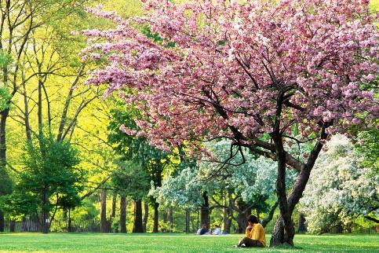 | 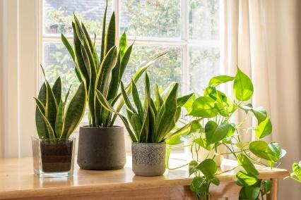 | 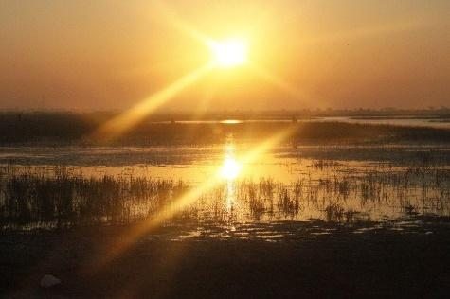
Springtime with trees in bloom | House plants | Sunset over a lake
A wonderful serenity has taken possession of my entire soul, like these sweet mornings of spring (Figure 1) which I enjoy with my whole heart. I am alone, and feel the charm of existence in this spot, which was created for the bliss of souls like mine. I am so happy, my dear friend, so absorbed in the exquisite sense of mere tranquil existence, that I neglect my talents. I should be incapable of drawing a single stroke at the present moment; and yet I feel that I never was a greater artist than now. When, while the lovely valley teems with vapour around me, and the meridian sun (Figure 3) strikes the upper surface of the impenetrable foliage of my trees, and but a few stray gleams steal into the inner sanctuary, I throw myself down among the tall grass by the trickling stream; and, as I lie close to the earth, a thousand unknown plants (Figure 2) are noticed by me: when I hear the buzz of the little world among the stalks, and grow familiar with the countless indescribable forms of the insects and flies, then I feel the presence of the world, which formed us and created us.

Part 1 - Photovoice Reflection Prompts
Photovoice Reflection Prompt A (Entrepreneurial Integration): The entrepreneurial mindset is defined as “the inclination to discover, evaluate, and exploit opportunities.” Explain how participating in the newly developed curriculum integrated the entrepreneurial mindset, and lessons learned relevant to the entrepreneurial mindset.
<Insert Picture 1> | <Insert Picture 2> | <Insert Picture 3>
<Insert Caption 1> | <Insert Caption 1> | <Insert Caption 1>
<Insert Narrative (200 word minimum)>

Photovoice Reflection Prompt B (STEAM): STEAM (science, technology, engineering, arts, math) goes one step beyond the well-known STEM to acknowledge the importance of integrating the arts and humanities into more analytical coursework such as that found within engineering. Art can be incorporated through pieces, process, and movements. Explain how participating in the newly developed curriculum incorporated STEAM (specifically, the arts), and lessons learned relevant to STEAM (specifically, the arts).
<Insert Picture 1> | <Insert Picture 2> | <Insert Picture 3>
<Insert Caption 1> | <Insert Caption 1> | <Insert Caption 1>
<Insert Narrative (200 word minimum)>

Photovoice Reflection Prompt C (Bio-Inspired Design): Bio-inspired design uses the nature-focused context of sustainability, security, and/or biomedicine and health outcomes to motivate analogical thinking and improve the engineering design process. Explain how participating in the newly developed curriculum incorporated bio-inspired design and lessons learned relevant to bio-inspired design.
<Insert Picture 1> | <Insert Picture 2> | <Insert Picture 3>
<Insert Caption 1> | <Insert Caption 1> | <Insert Caption 1>
<Insert Narrative (200 word minimum)>

Part 2 - Metacognitive Reflection Prompts
Direction: Please respond to the open-ended reflection questions with a minimum of 200 words per questions. Be sure to check assignment for spelling and grammar prior to submission.
Open-Ended Reflection Question A (Interdisciplinarity): The interdisciplinary approach of integrating the entrepreneurial mindset, STEAM (specifically, the arts), and bio-inspired design has been shown to improve student engagement, motivation and learning outcomes. How did this interdisciplinary learning experience affect your ability to engage with the newly developed curriculum?
<Insert Narrative (200 word minimum)>

Open-Ended Reflection Question B (Debrief): What went well? What didn’t go so well? What will you do differently next time?
<Insert Narrative (200 word minimum)>

Open-Ended Reflection Question C (Connect to Real World): What skills did you learn? Please consider both professional skills (e.g., communication, collaboration, etc…) and context specific skills (e.g., topic area). Why are these skills important for engineers in the real world?
<Insert Narrative (200 word minimum)>

